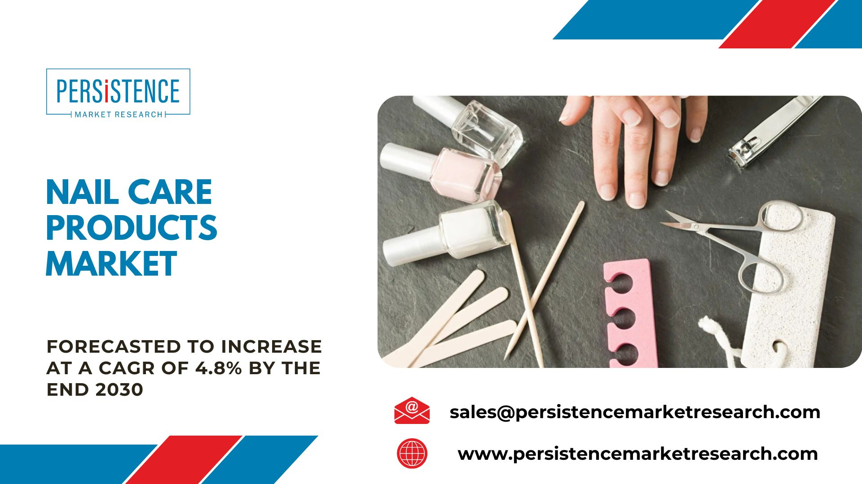

**A Deep Dive into the Nail Care Products Market**

The nail care products market encompasses a diverse range of items, including nail polishes, nail polish removers, nail treatments, and accessories. According to market research, the global nail care industry is projected to reach new heights in the coming years, fueled by the increasing disposable income of consumers, rising beauty consciousness, and the proliferation of nail art trends.

**Market Overview**

Definition and Scope

Nail Care Products encompass a wide range of products designed to enhance and maintain the health and appearance of nails. These include nail polishes, nail strengtheners, cuticle care products, and nail tools.

Market Size and Growth Trends

The [**global nail care products market**](https://www.persistencemarketresearch.com/market-research/nail-care-products-market.asp) is forecast to expand at a CAGR of **4.8%**and thereby increase from a value of **US$23.4 Billion** in 2023, to **US$32.5 Billion**by the end of 2030. The increasing popularity of at-home nail care routines, the rise of social media influencing beauty trends, and a surge in demand for natural and organic nail care products are key drivers of market expansion.

**Trends Shaping the Industry:**

Clean Beauty and Sustainability: Modern consumers are increasingly conscious of the ingredients in their beauty products. The demand for clean and eco-friendly nail care options has led to the emergence of sustainable and cruelty-free brands. Consumers are scrutinizing ingredient lists, pushing manufacturers to adopt transparent practices and environmentally friendly packaging.

Nail Art and Expression: Nail art has evolved from a niche trend to a mainstream form of self-expression. Social media platforms like Instagram and Pinterest have become hubs for nail art enthusiasts, driving the demand for a variety of nail polishes, decals, and embellishments. Brands are capitalizing on this trend by collaborating with nail artists and launching innovative nail art kits.

Health and Wellness Integration: Nail care is increasingly seen as an integral part of overall health and wellness. Nail treatments infused with vitamins, minerals, and other nourishing ingredients are gaining popularity. Consumers are looking for products that not only enhance the aesthetics of their nails but also contribute to their overall nail health.

**Innovations in Nail Care Products:**

Smart Nail Technology: The integration of technology into beauty products is not limited to skincare and haircare. Smart nail technology, including temperature-changing polishes, LED gel polishes, and even nail art printers, is making waves in the market. These innovations add a futuristic touch to traditional nail care routines.

Long-Lasting Formulations: Consumers are increasingly seeking nail polishes that offer longevity without compromising on appearance. Long-lasting formulations, such as gel polishes and hybrid nail lacquers, have gained popularity. These products cater to individuals with busy lifestyles who desire manicures that withstand daily activities.

Customization and Personalization: Brands are recognizing the value of offering personalized nail care solutions. Customizable nail polishes, where consumers can mix and match colors to create their unique shades, are becoming more prevalent. Personalized nail treatments targeting specific concerns, such as nail strengthening or cuticle care, are also on the rise.

**Consumer Preferences:**

Online Shopping and Influencer Impact: The shift towards online shopping has significantly impacted the way consumers discover and purchase nail care products. Social media influencers and beauty bloggers play a crucial role in shaping consumer preferences. Authentic reviews and tutorials contribute to the success of products, making influencer collaborations a key marketing strategy for brands.

Brand Loyalty and Trust: Consumers are becoming more discerning in their choices, gravitating towards brands that prioritize transparency, authenticity, and ethical practices. Brand loyalty is built on trust, and consumers are more likely to remain loyal to companies that align with their values, whether it be cruelty-free practices, sustainability initiatives, or inclusivity.

Affordability and Accessibility: While premium and luxury nail care brands continue to thrive, there is a growing demand for affordable yet effective options. Accessibility is a key factor, with consumers seeking products that deliver quality results without breaking the bank. This has led to the rise of budget-friendly nail care lines that cater to a diverse range of consumers.

**Market Drivers:**

Personal Grooming Trends: The global emphasis on personal grooming and self-care is a primary driver for the Nail Care Products market. Consumers are increasingly investing in nail care routines as a form of self-expression and self-indulgence.

Nail Art Culture: The flourishing trend of nail art, fueled by social media platforms and influencers, is driving the demand for a variety of nail polishes, embellishments, and tools. Nail salons and at-home users are contributing to the expansion of this segment.

Rising Awareness of Nail Health: Growing awareness of the importance of nail health is propelling the market. Consumers are seeking products with formulations enriched with vitamins and nourishing ingredients to promote strong and healthy nails.

Innovation in Formulations: Continuous innovation in nail care product formulations, including the development of long-lasting polishes, quick-drying solutions, and eco-friendly options, is attracting consumers and driving market growth.

**Market Restraints:**

Environmental Concerns: The Nail Care Products market faces challenges related to environmental sustainability. Issues such as the disposal of nail polish containers and the environmental impact of certain ingredients pose potential constraints on market growth.

Allergies and Sensitivities: Some individuals may experience allergies or sensitivities to certain nail care ingredients. Formulating products that cater to sensitive skin types while maintaining effectiveness is a challenge for market players.

Competition from Nail Salons: The availability of professional nail services in salons poses competition to at-home nail care products. Market players need to differentiate their offerings to attract consumers who prefer DIY nail care.

**Market Opportunities and Challenges:**

Opportunity:

Online Retailing: The rise of e-commerce provides a significant opportunity for Nail Care Products. Companies can leverage online platforms to reach a broader consumer base, offer tutorials, and engage with customers directly.

Nail Health Education: Educating consumers about nail health and the benefits of different nail care products presents an opportunity. Collaborations with dermatologists and influencers can enhance awareness and promote product adoption.

Challenge:

Regulatory Compliance: Adhering to regulatory standards for cosmetic products poses a challenge. Staying informed about evolving regulations and ensuring product safety and labeling compliance is crucial for market players.

Product Differentiation: The Nail Care Products market is highly competitive, requiring companies to continually innovate and differentiate their products. Creating unique formulations, introducing trendy colors, and offering customizable options are avenues for product distinction.

**Global Industry Analysis, Size, Share, Growth, Trends, and Forecast 2023-2030:** [**https://www.persistencemarketresearch.com/market-research/nail-care-products-market.asp**](https://www.persistencemarketresearch.com/market-research/nail-care-products-market.asp)

**Market Segmentations**

By Product Type:

* Nail polish
* Top and Base coats
* Nal polish removers
* Cuticle care
* Others

By Distribution Channel:

* Offline
* Online

**Regional Market Dynamics**

North America: The North American Nail Care Products market is prominent, driven by a culture of self-expression, a strong beauty industry, and the influence of social media on beauty trends.

Europe: Europe is a significant player in the Nail Care Products market, with a focus on eco-friendly and organic formulations. Consumer demand for premium and innovative products is shaping the market in the region.

Asia-Pacific: The Asia-Pacific region is experiencing rapid market growth, attributed to the influence of K-beauty trends, a rising middle-class population, and the increasing adoption of at-home beauty routines.

**Key Players**

The Nail Care Products market is characterized by both established and emerging players. Some prominent companies include:

* OPI Products Inc.
* Essie
* Sally Hansen
* Revlon
* Coty Inc.
* Chanel
* Orly International
* Shiseido Company Limited

**Future Projections:**

The future of the Nail Care Products market is promising, driven by a combination of evolving beauty trends and the influence of social media. The market is expected to witness further diversification with the introduction of specialty nail care products targeting specific concerns such as nail strength, hydration, and anti-aging.

Sustainability initiatives, including eco-friendly packaging and cruelty-free formulations, are likely to become more prevalent as consumers become increasingly conscious of their environmental impact. Furthermore, the integration of technology for personalized and interactive nail care experiences is anticipated to shape the market's trajectory.

**COVID-19's Impact:**

The COVID-19 pandemic has influenced the Nail Care Products market in multiple ways. While the initial disruption resulted in supply chain challenges and temporary closures of beauty salons, the lockdowns prompted a surge in at-home grooming activities.

Consumers turned to DIY nail care, contributing to increased sales of nail polish, treatments, and tools. The experience of at-home nail care has influenced long-term habits, with consumers continuing to invest in nail care products even as salon services resume.

**Key Questions Answered in the Report:**

* What are the current trends in the Nail Care Products market?
* How are technological innovations shaping the landscape of nail care product development?
* What is the regulatory framework governing the manufacturing and marketing of nail care products?
* What are the investment opportunities and associated risks in the market?
* How has the COVID-19 pandemic impacted the Nail Care Products market?
* What are the future projections for the market, considering evolving trends?
* Who are the key players in the Nail Care Products market, and what are their strategies?
* How do regional factors influence market trends and opportunities?
* What emerging technologies are expected to impact the Nail Care Products market?
* How does the competitive landscape look, and what is the market positioning of key players?

**Read More Trending “PMR Exclusive Article”:**

* [**Market Study on Natural Cosmetic Ingredients**](https://prnewssync.wordpress.com/2023/12/21/the-natural-cosmetic-ingredients-market-to-climb-the-exponential-growth-curve/)
* [**Market Study on CBD Skin Care**](https://issuu.com/fmrresearch/docs/cbd_skin_care_market.pptx)

**About Persistence Market Research:**

Business intelligence is the foundation of every business model employed by Persistence Market Research. Multi-dimensional sources are being put to work, which include big data, customer experience analytics, and real-time data collection. Thus, working on “micros” by Persistence Market Research helps companies overcome their “macro” business challenges.

Persistence Market Research is always way ahead of its time. In other words, it tables market solutions by stepping into the companies’/clients’ shoes much before they themselves have a sneak pick into the market. The pro-active approach followed by experts at Persistence Market Research helps companies/clients lay their hands on techno-commercial insights beforehand, so that the subsequent course of action could be simplified on their part.

**Contact Us:**

Persistence Market Research  
Teerth Technospace, Unit B-704  
Survey Number - 103, Baner  
Mumbai Bangalore Highway  
Pune 411045, India  
Email: [sales@persistencemarketresearch.com](mailto:sales@persistencemarketresearch.com)  
**Web:**[**https://www.persistencemarketresearch.com**](https://www.persistencemarketresearch.com)